LONTIUM SEMICONDUCTOR CORPORATION

LT8911EXB Linux Driver
Software
configuration and debugging guide

目 录
一 Introduction 3
二 Driver File Introduction 5
三 Added To The Kernel Method 7
四 LT8911EXB Software Configuration 9

一 Introduction

- The LT8911EXB does not have a built-in MCU, and requires an external MCU or SOC to read and write registers to the chip through the I2C to work normally.
- The chip register address is 16 bits (the actual read and write operation is based on 8-bit address, the read and write timing can refer to 8-bit address), in which the high 8 bits are the Bank address, and the low 8 bits are the offset address in the Bank.
For example, chip id register 0x8102, 0x81 is the bank address, and 0x02 is the offset address in the bank. Bank must be specified before register read and write. Register read and write in the same Bank need not be specified repeatedly. Cross-bank operation must first select the corresponding Bank address. As shown in the following figure, HDMI_WriteI2C_Byte(0xff,0x81) specifies that the bank is 0x81, and HDMI_ReadI2C_Byte(0x02) is the register that reads the address 0x02 in 0x81bank.
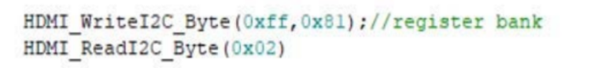

- The chip can output internal test images independently of the input signal.
- The LT8911EXB's I2C address is 8-bit 0x52 and 0x5A used on the MCU, and can be selected by the address pin setting, refer to the reference schematic for details.
However, when using a 7-bit address on an SOC, the address given by Lontium needs to be shifted one bit to the right, as shown below:

二 Driver File Introduction

① Driver file layout：
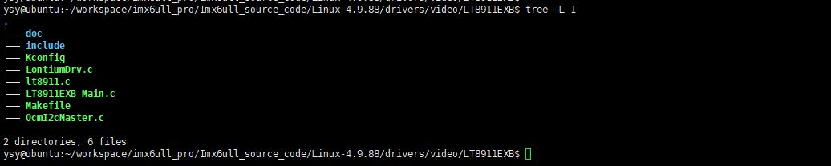
The main documents are described as follows:
- LontiumDrv.c: Linux driver entry file. view the driver logic from this file
- LT8911EXB_Main.c: The chip configuration entry file is where the chip configuration logic begins.
- include: Store all header files of the driver.
- Makefile: The configuration file is used to build the driver.
- Kconfig : The configuration file is used to build the driver.
- doc: Directory for storing the introduction document
- Other files: Provides functions that are called during register configuration.

② LontiumDrv.c source code introduction：
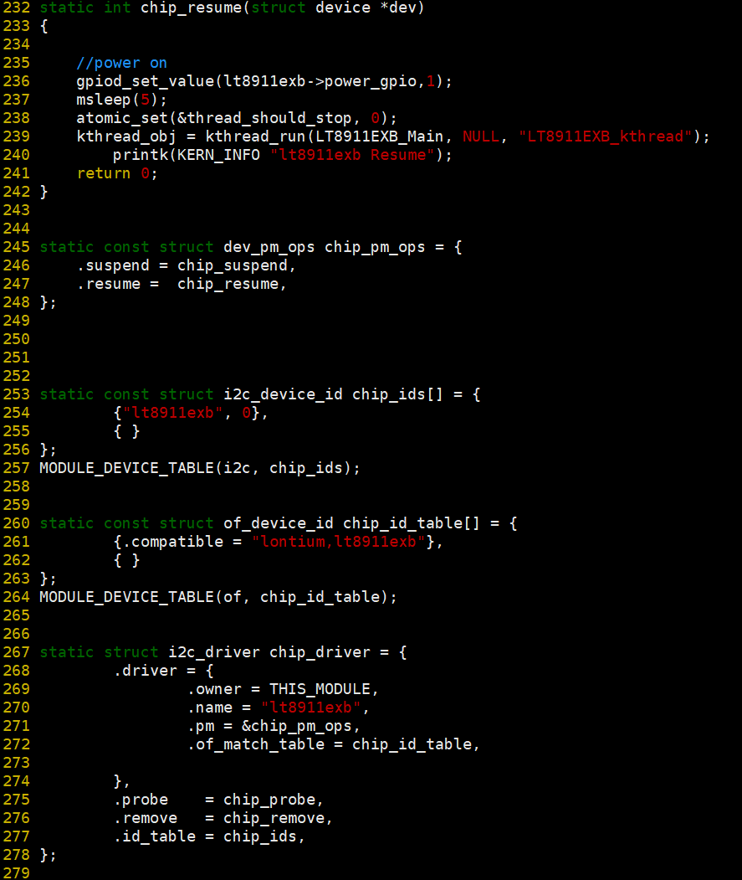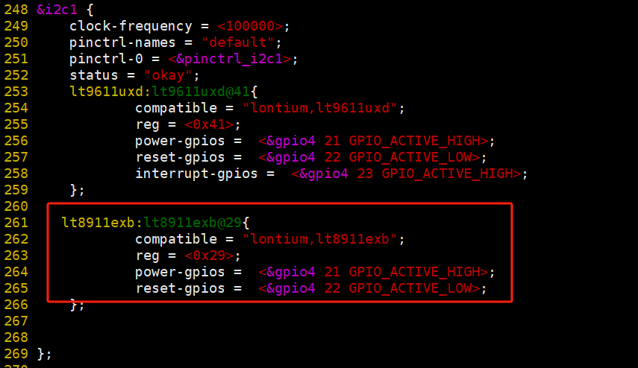

- "lontium,lt8911exb": Key characters that match the device tree.
- chip_probe ： Once the driver matches the device tree when loaded, chip_probe is executed.
- chip_pm_ops： Register the sleep function -chip_suspend and wake function -chip_resume, if the platform's power cannot use driver control, here you can use the following to control the reset pin：
static int chip_suspend(struct device *dev)
{
atomic_set(&thread_should_stop, 1);
kthread_stop(kthread_obj);
msleep(5);
gpiod_set_value(lt8911exb->reset_gpio,0); //reset pin Pull low - Low power consumption
printk(KERN_INFO "LT8911EXB Suspend");
return 0;
}
static int chip_resume(struct device *dev)
{
gpiod_set_value(lt8911exb->reset_gpio,1); //reset pin pull high - Returns to normal
msleep(5);
atomic_set(&thread_should_stop, 0);
kthread_obj = kthread_run(LT8911EXB_Main, NULL, "LT8911EXB_kthread"); //reinitialize LT8911EXB
printk(KERN_INFO "LT8911EXB Resume");
return 0;
}

③ chip_probe source code introduction：
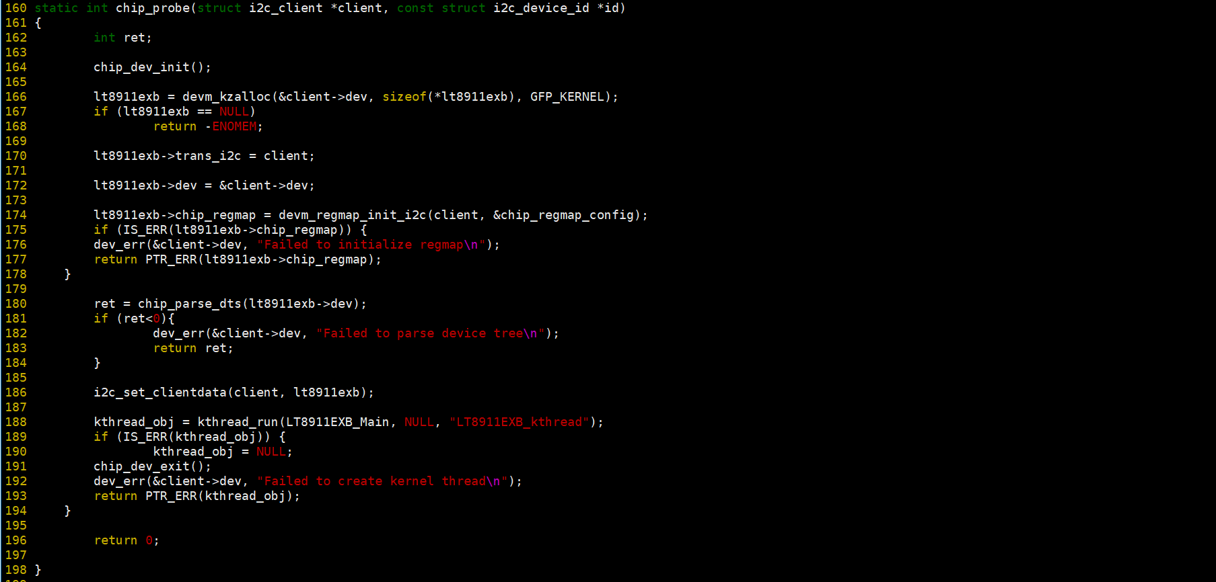
- ret = chip_parse_dts(lt8911exb->dev): Parses the GPIO resources configured in the device tree.
- kthread_obj = kthread_run(LT8911EXB_Main, NULL, "LT8911EXB_kthread"): Create a thread, call LT8911EXB_Main function, LT8911EXB_Main function will initialize the chip.

三 Add To The Kernel Method

- Take the driver/video directory added to the kernel as an example. Create the LT8911EXB folder in the video directory:
Copy the provided driver source file into the LT8911EXB directory and configure the driver/video/Makefile and driver/video/Kconfig files that already exist in the video directory:
  - driver/video/Makefile:
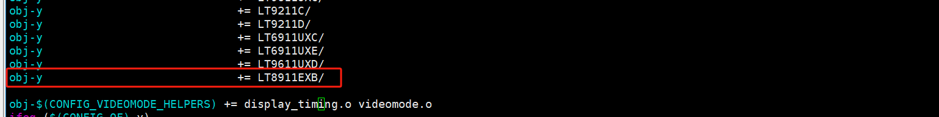
  - driver/video/Kconfig:
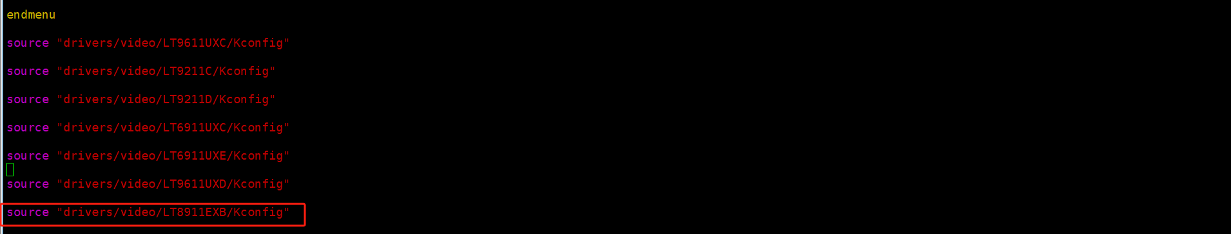

- Go to the LT8911EXB directory and add the driver/video/LT8911EXB/Makefile and driver/video/LT8911EXB/
Kconfig, the source code for these two files is provided, and the configuration content is as follows:
  - driver/video/LT8911EXB/Makefile:

  - driver/video/LT8911EXB/Kconfig:
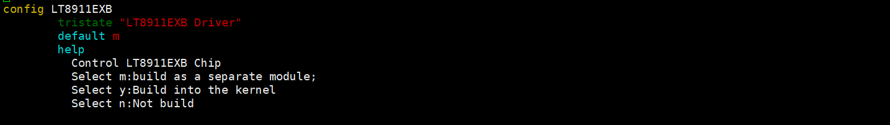

③ Execute the make menuconfig command in the kernel directory, and then configure the added driver to participate in compilation at compile time.
- At the red line below, select M to compile into a separate ko, which requires manual insmod.
- Select y to be automatically loaded when the kernel starts.
- Select n not to participate in compilation.
- Click Save and Exit to add the configuration to the configuration file .config, and then build.

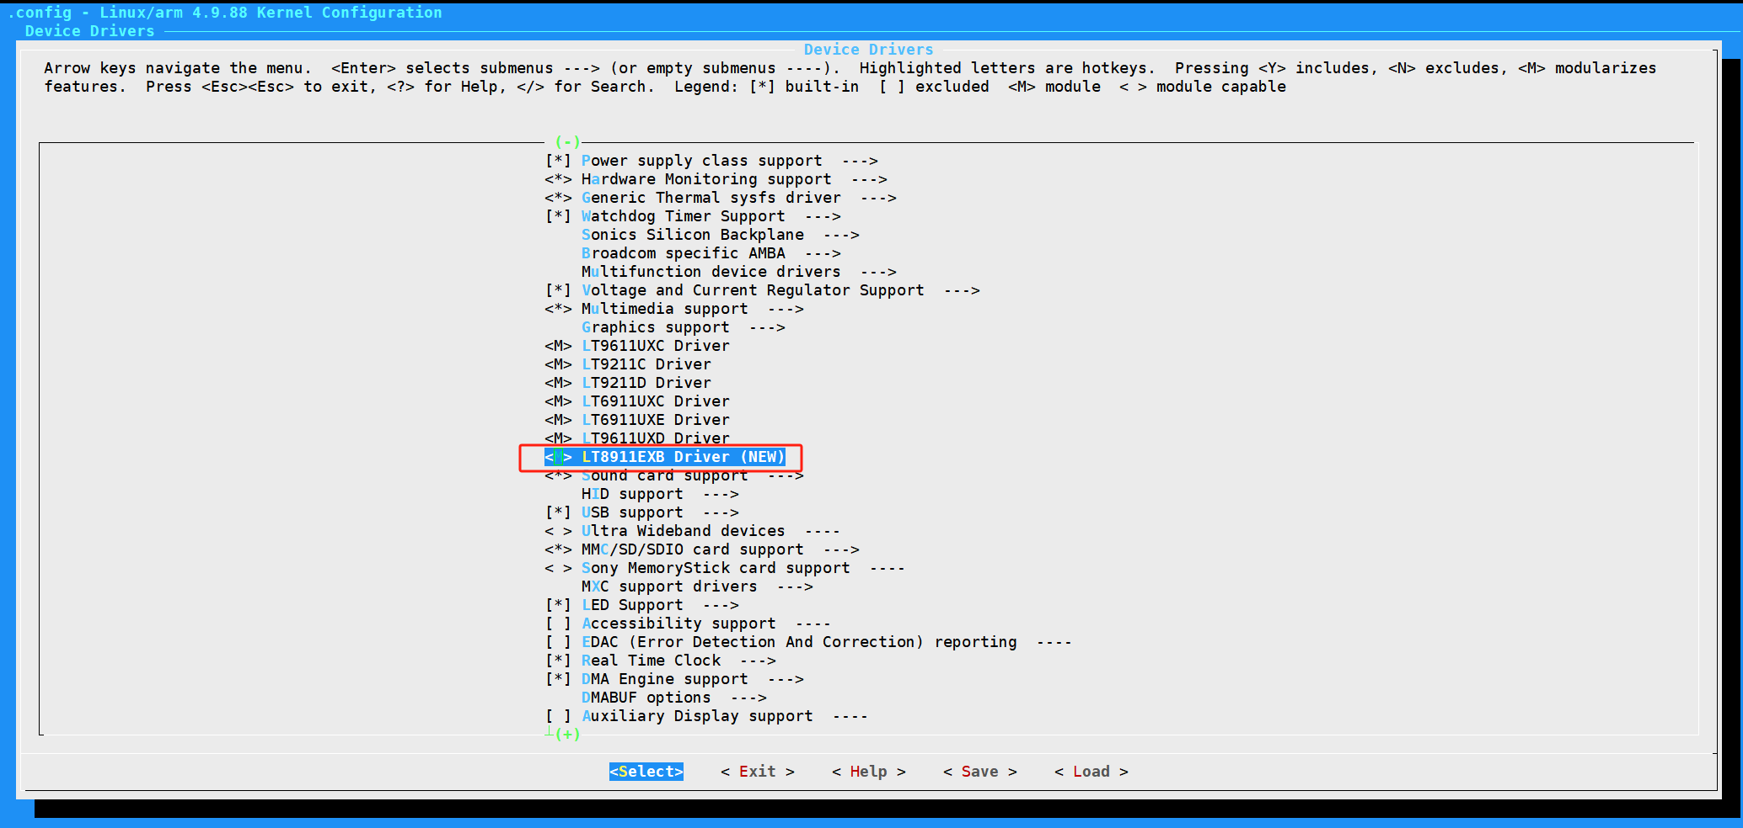

[NOTE]：Can also set CONFIG_LT8911EXB to a fixed value in xxxx_defconfig for your platform, so that you don't need make menuconfig.

四 LT8911EXB Software Configuration

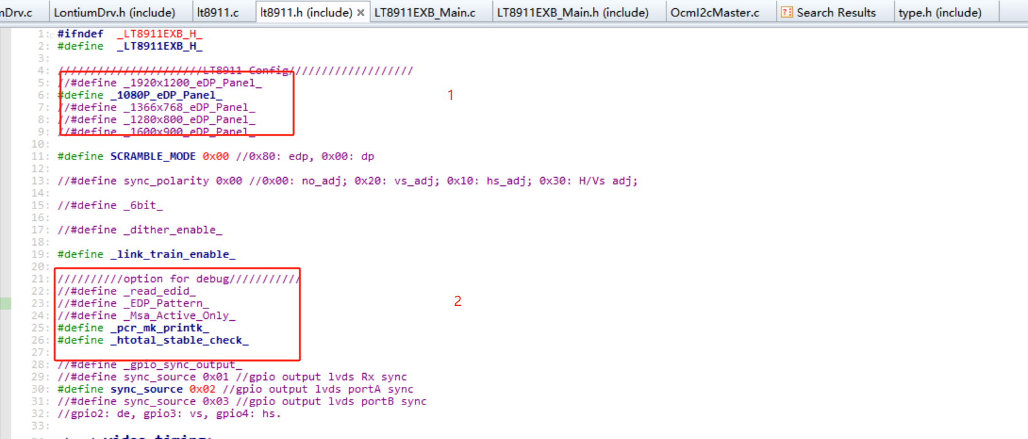
- Configure the output resolution as required,such as #define _1080P_eDP_Panel_ ，output 1080p.
- #define _EDP_Pattern_: output pattern.

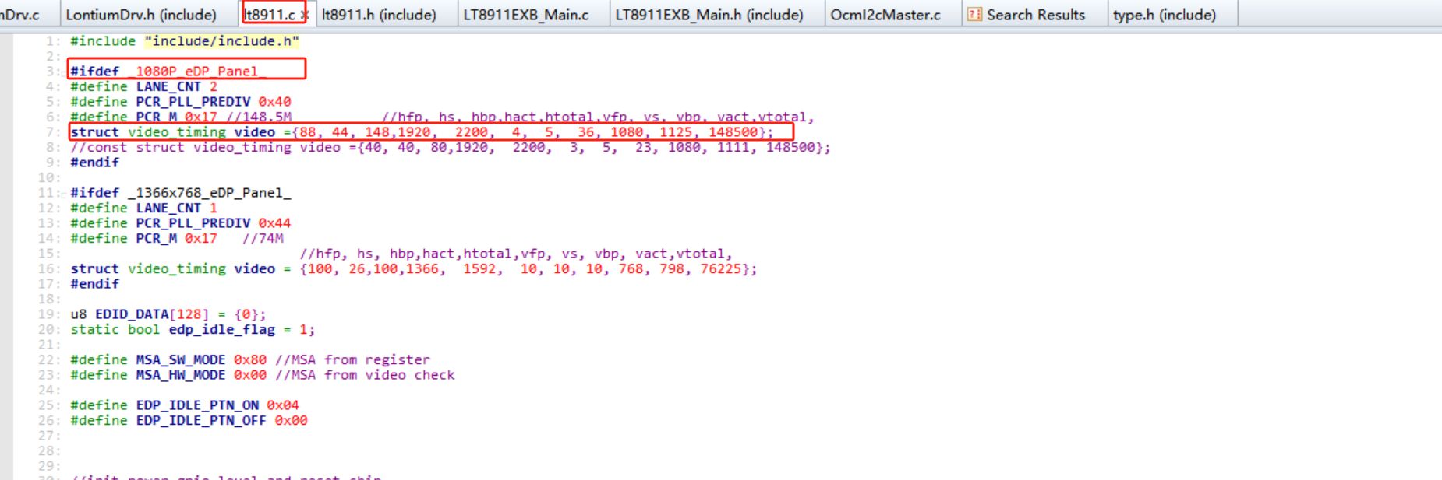
- _1080P_eDP_Panel_ is used here.
- struct video_timing video = {}：Fill in specific timing information.

